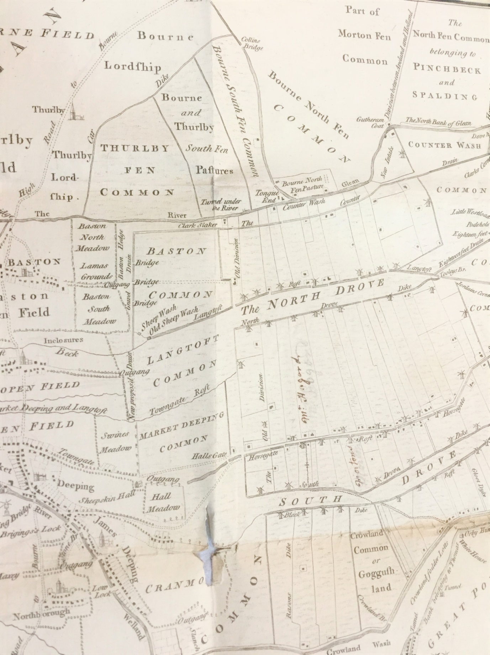

***Understanding Fenland Landscape and Society:***

***Past and Present***

**Reviewing the latest research into the landscape and society of the Fenland from the Roman to the Early Modern period.**

**SATURDAY 13TH APRIL 2019**

**10am to 4:30pm (registration 9:30-10am)**

**Broad Street Methodist Church,**

**Spalding, Lincolnshire, PE11 1TB**

**Standard Tickets: £20 incl. lunch**

**Student Concessions: £10 incl. lunch**

To register, please fill in the form below and return it with a cheque made payable to ‘Spalding Gentlemen’s Society’ to:

Spalding Gentlemen’s Society

The Museum, Broad Street, Spalding, PE11 1TB

|  |  |
| --- | --- |
| **Name** |  |
| **Address** |  |
| **Post Code** |  |
| **Telephone/Mobile** |  |
| **Email** |  |
| **Number of Tickets** | **Standard** **Student Concessions**  **Institution** |
| **Special dietary requirements** |  |

*Please note there is no immediate parking at the venue there are public car parks nearby. For current parking information & availability go to: www.sholland.gov.uk/carparks